Film: Gatecrash
Director: Lawrence Gough
Stars: Olivia Bonamy, Ben Cura, Anton Lesser & Samuel West
Genre: Drama / Thriller

Run time: 1hr 28min
Rated: 15
Rating: 3/5 (Double Click for Audio Listening)

Gatecrash
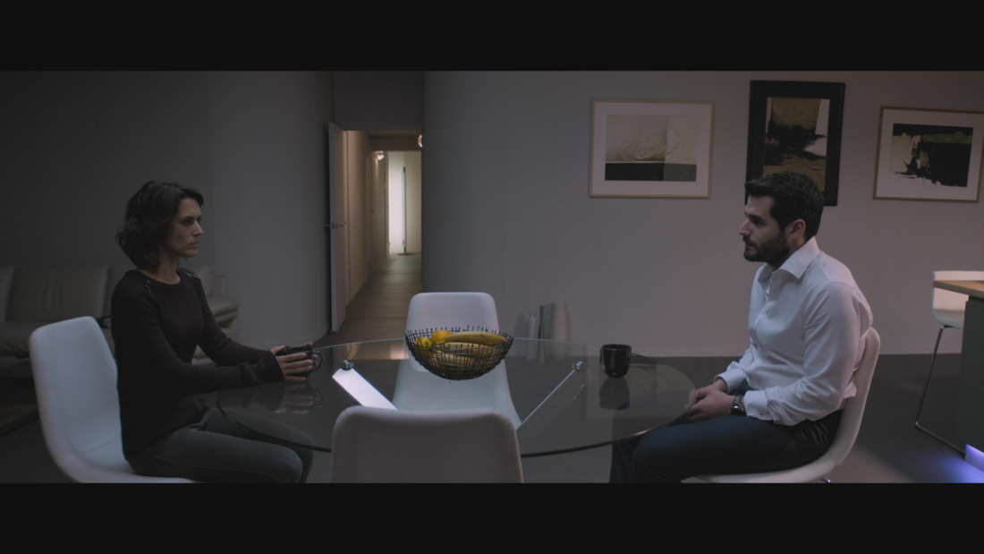
Directed by Lawrence Gough and based on an award-winning play by Terry Hughes the film begins with Steve and his French wife Nicole returning home after a hit and run incident. Their relationship seems already strained made all the worse by the ‘accident’. The accusations that spill out quickly become threatening as they attempt to figure out a plan as to what to do next.

Things take a further turn for the worse when an oddball policeman turns up at the house at which point Steve makes a sharp exit, leaving his wife to deal with some awkward questioning. As the policeman takes a look around their luxury pad and disappears, Nicole goes looking for him in the labyrinth of rooms only to discover a trail of blood.

When we catch up with them there is a surprising switch in circumstances as the policeman takes the law into his own hands and gives some interesting marriage counselling. This all happens before Sid the actual victim of the incident turns up at the house some years later. We know some time has elapsed because Nicole has had a baby, a seemingly curious plot thread, introduced when she felt the need to take a timely pregnancy test during the height of the initial crisis.

Sid, a kind, softly spoken older man arrives at the house unannounced to thank the couple he believes helped him on the night of the accident. The interplay between the characters has the feel of the original play with plenty of heated conversations. Olivia Bonamy’s performance demands empathy as the bullied wife who gets trapped by a succession of tormentors, most notably her horribly obnoxious husband.

Set in a modern country house situated somewhere in a secluded part of the English countryside the film doesn’t hang around getting down to the scruples of the incident. Were they arguing in the car? Was he drink driving? …but then reversing over the victim?! This is a stylised British psychological thriller that borders on a farcical horror. The tension builds assisted by some creepy sound mixing before a vengeful finale.

Similar films:
- Crash (1996); Dir: David Cronenburg; Stars: James Spader, Holly Hunter
- Crash (1994); Dir: Paul Haggis; Stars: Don Cheadle, Matt Dillion, Sandra Bullock
- Closer (2004); Dir: Mike Nichols; Stars: Jude Law, Julia Roberts, Natalie Portman
Exercises:

A. Questions True or False:
1. The film was originally a play? T/F?
2. Nicole finds the policeman searching the house? T/F?
3. The policeman plays it by the book? T/F?
4. Sid is very grateful the couple helped him? T/F?
5. Nicole’s husband is loving and caring? T/F?
6. The house is located in a village in the countryside? T/F?

B. Vocabulary / Phrases Match
- hit and run
- spill out
- oddball
- pad
- catch up
- plot thread
- interplay
- obnoxious
- hang around
- scruples

- stay
- storyline
- interaction
- get together
- flow out
- moral dilemma
- strange person
- home
- road accident
- unpleasant

C. Discussion Questions:

1. Describe what you see in the picture.
2. What do most couples argue about?
3. Do you think the justice system is fair? Why? Why not?
4. Do you know what penalties are given for crimes in your country?
5. Has the attitude towards drink driving changed over time?

D. Pronunciation & Listening Exercise:
a. Listen to the phrases and practise your pronunciation (double click the icons).
1. Directed by Lawrence Gough and based on an award-winning play.
2. When we catch up with them there is a surprising switch in circumstances.
3. The film doesn’t hang around getting down to the scruples of the incident.

b. Listen to the text and fill the missing gaps (see text below).
(double click the icon)

E. Writing tasks:
- Write an essay to discuss should the death penalty be reintroduced?

Answers:
A. True or False Questions:
- T 2. F 3. F 4. T 5. F 6. F

B. Vocabulary Definitions:
1i, 2e, 3g, 4h, 5d, 6b, 7c, 8j, 9a, 10f

C. Listening Gap Fill
1. relationship 2. questioning 3. marriage counselling 4. empathy 5. secluded

Listening Gap Fill

Gatecrash
Directed by Lawrence Gough and based on an award-winning play by Terry Hughes the film begins with Steve and his French wife Nicole returning home after a hit and run incident. Their 1. _______ seems already strained made all the worse by the ‘accident’. The accusations that spill out quickly become threatening as they attempt to figure out a plan as to what to do next.

Things take a further turn for the worse when an oddball policeman turns up at the house at which point Steve makes a sharp exit, leaving his wife to deal with some awkward 2. _______ . As the policeman takes a look around their luxury pad and disappears, Nicole goes looking for him in the labyrinth of rooms only to discover a trail of blood.

When we catch up with them there is a surprising switch in circumstances as the policeman takes the law into his own hands and gives some interesting 3. _______ _______ . This all happens before Sid the actual victim of the incident turns up at the house some years later. We know some time has elapsed because Nicole has had a baby, a seemingly curious plot thread, introduced when she felt the need to take a timely pregnancy test during the height of the initial crisis.

Sid, a kind, softly spoken older man arrives at the house unannounced to thank the couple he believes helped him on the night of the accident. The interplay between the characters has the feel of the original play with plenty of heated conversations. Olivia Bonamy’s performance demands 4. _______ as the bullied wife who gets trapped by a succession of tormentors, most notably her horribly obnoxious husband.

Set in a modern country house situated somewhere in a 5. _______ part of the English countryside the film doesn’t hang around getting down to the scruples of the incident. Were they arguing in the car? Was he drink driving? …but then reversing over the victim?! This is a stylised British psychological thriller that borders on a farcical horror. The tension builds assisted by some creepy sound mixing before a vengeful finale.

