Film: Tokyo Dragon Chef
Director: Yoshihiro Nishimura
Stars: Yasukaze Motomiya, Yoshiyuki Yamaguchi, Hitoshi Ozawa, Kazuyoshi Ozawa, Tak Sakaguchi
Genre: Action / Comedy

Run time: 1hr 35min
Rated: 15

Rating: 3/5
(Double Click for Audio Listening)

Tokyo Dragon Chef
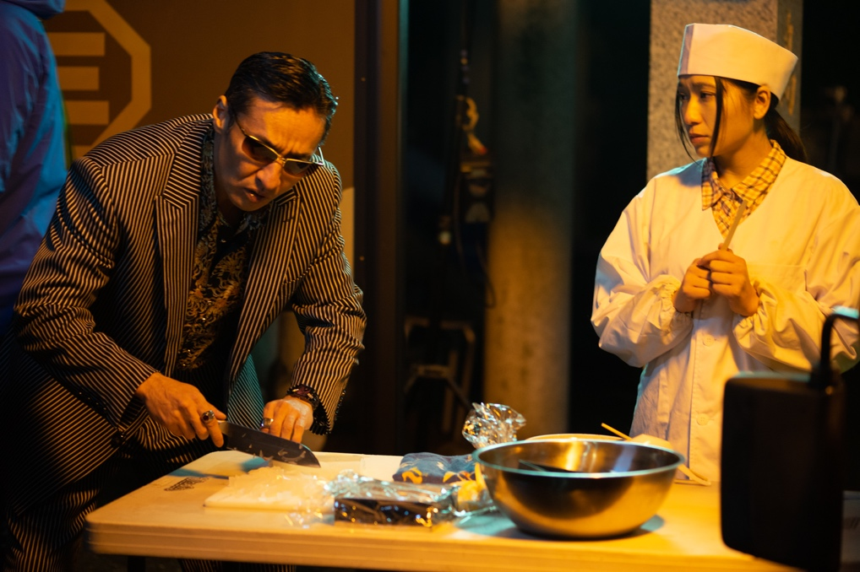
This is a Japanese action comedy by Yoshihiro Nishimura, described as a “legendary director and effects artist” and renowned for his work predominantly in the horror genre, here he creates a crazy comedy alternative to the yakuza crime stories based on ramen noodles, with little to no gore.

The story begins with 2 ex-yakuza brothers being reunited after one of them, Tatsu, finishes a term in prison. His brother, Ryu, is looking to put his yakuza fighting days behind him and he is selling nato de coco drinks from his food truck. Tatsu is unimpressed especially with the food truck but when he gets a taste for the ramen noodles, he suddenly sees the light and has to put his chefing skills to good use.

Their restaurant business takes off when they get a visit from a YouTuber who gives their Tokyo Dragon restaurant sensational reviews. But it can’t last long and when an old yakuza rival gang show up, the Ozawa Brothers, there is a ramen noodle turf war hotting-up.

Meanwhile there is Gizumo who is the young start-up looking for revenge on the yakuza who ruffed him up. He’s now a tech whizz looking to take over from the old yakuza with his own gang of enforcers going around putting the competition out of business.

There are some American influences throughout the film especially with the music and rock n roll. The songs switch between Japanese and English and a couple of scenes make a link between the languages. The first is where Gizumo has a funny turn and starts singing in English, “Merry Christmas and a Happy New Year”, in an intoxicated brainwashed trance, then the next scene shows Tatsu changing the complicated Japanese lettering outside the restaurant. Put the two side by side and you get the idea how crazy the language differences are.

The idea of these violent yakuza starting a noodle restaurant is only the beginning of the non-stop gags and parody of Japanese films. This gives a great flavour of Japanese film tastes without taking itself too seriously and if you can do the same you will enjoy the madcap intense noodle tasting, which is quite special to watch.

Similar films:
- Tampopo (1985); Dir: Juzo Itami; Stars: Ken Watanabe, Tsutomu Yamazaki
- Jiro Dreams of Sushi (2011); Dir: David Gelb; Stars: Jiro Ono, Yashikazu Ono
Exercises:

A. Questions True or False:
1. The director is well known for his comedy films? T/F?
2. Ryu wants to move on from his yakuza days? T/F?
3. Their restaurant gets bad reviews from a YouTuber? T/F?
4. Their restaurant business is under threat from some competition? T/F?
5. Gizumo is very good with using technology? T/F?
6. All the music is in Japanese? T/F?

B. Vocabulary / Phrases Match:
- yakuza
- gore
- see the light
- uncanny
- turf war
- hotting up
- tech whizz
- funny turn
- brainwashed
- madcap

- understand
- acting weird
- territorial competition
- increasing interest
- Japanese gang
- told what to think
- blood
- crazy
- technology expert
- strange

C. Discussion Questions:
1. Describe what you see in the picture.
2. Do you like cooking? Why? Why not?
3. Would you like to run your own food truck? Why? Why not?
4. Is social media a good way to advertise your business?
5. Is learning a language like brainwashing?
D. Pronunciation & Listening Exercise:
a. Listen to the phrases and practise your pronunciation (double click the icons).
1. The story begins with 2 ex yakuza brothers being reunited.
2. There are some American influences throughout the film.
3. This gives a great flavour of Japanese film tastes.

b. Listen to the text and fill the missing gaps (see text below).
(double click the icon)

E. Writing tasks:
- Describe a restaurant business you would like to run.

Answers:
A. True or False Questions:
- F 2. T 3. F 4. T 5. T 6. F

B. Vocabulary Definitions:
1e, 2g, 3a, 4j, 5c, 6d, 7i, 8b, 9f, 10h

C. Listening Gap Fill
1. horror genre 2. Food truck 3. Revenge 4. Restaurant 5. noodle tasting
Listening Gap Fill

Tokyo Dragon Chef
This is a Japanese action comedy by Yoshihiro Nishimura, described as a “legendary director and effects artist” and renowned for his work predominantly in the 1._______ _______, here he creates a crazy comedy alternative to the yakuza crime stories based on ramen noodles, with little to no gore.

The story begins with 2 ex-yakuza brothers being reunited after one of them, Tatsu, finishes a term in prison. His brother, Ryu, is looking to put his yakuza fighting days behind him and he is selling nato de coco drinks from his 2. _______ _______. Tatsu is unimpressed especially with the food truck but when he gets a taste for the ramen noodles, he suddenly sees the light and has to put his chefing skills to good use.

Their restaurant business takes off when they get a visit from a YouTuber who gives their Tokyo Dragon restaurant sensational reviews. But it can’t last long and when an old yakuza rival gang show up, the Ozawa Brothers, there is a ramen noodle turf war hotting-up.

Meanwhile there is Gizumo who is the young start-up looking for 3. _______ on the yakuza who ruffed him up. He’s now a tech whizz looking to take over from the old yakuza with his own gang of enforcers going around putting the competition out of business.

There are some American influences throughout the film especially with the music and rock n roll. The songs switch between Japanese and English and a couple of scenes make a link between the languages. The first is where Gizumo has a funny turn and starts singing in English, “Merry Christmas and a Happy New Year”, in an intoxicated brainwashed trance, then the next scene shows Tatsu changing the complicated Japanese lettering outside the 4. _______. Put the two side by side and you get the idea how crazy the language differences are.

The idea of these violent yakuza starting a noodle restaurant is only the beginning of the non-stop gags and parody of Japanese films. This gives a great flavour of Japanese film tastes without taking itself too seriously and if you can do the same you will enjoy the madcap intense 5. _______ _______, which is quite special to watch.

