Film: The Exception
Director: Jesper W. Nielsen
Stars: Danica Curcic, Amanda Collin, Sidse Babett Knudsen, Lene Maria Christensen
Genre: Drama / Thriller

Run time: 1hr 55min
Rated: 15

Rating: 3/5
(Double Click for Audio Listening)

The Exception
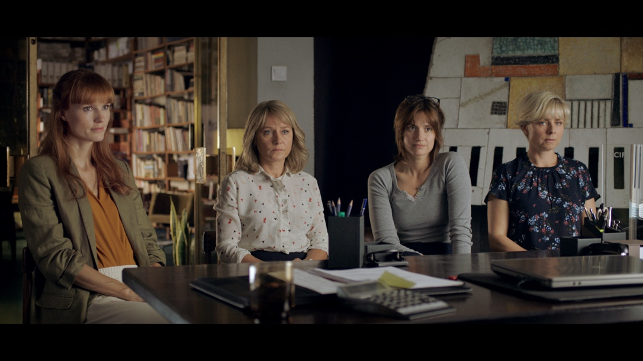
The Exception is a Danish psychological thriller based on the book by Christian Jungersen. The film opens with notes being written in a book Psychology of Evil 2, a study into the psychological tests of leading Nazis during the holocaust. The conclusions are unnerving and set the tone for the film.

The story centres around four women working at a Danish centre for information on genocide. Iben the author of the book was in Nairobi as an African aid worker and after being taken hostage is still dealing with the trauma. Malene, her best friend, is dealing with her own debilitating health issues. She is also worried about her job and thinks Anne-Lise is after it. Anne-Lise, their new co-worker is getting the cold shoulder for this reason, making life very difficult for her at the office. Then there is Camilla, the quiet one who goes along with what Malene and Iben say, except that she has a reoccurring sexual fantasy for her Serbian ex-boyfriend.

The 2 close friends Iben and Malene receive anonymous email threats from an unknown source and as the relationships at work deteriorate, they begin to suspect one and other, despite a long list of more likely suspects. With the intrigue and tension mounting all of this momentum is lost when the girls attempt to make a psychological appraisal of their colleague and accuse her of making the threats (when her only crime until then was a poor dinner party anecdote).
That’s perhaps where the message of this film lies, where the actions of ordinary people can harm one another as feelings and emotions get the better of them. Here, their determination to catch the other one out, leads them to do more baffling and illegal things.

The film interestingly compares the psychology of evil and war crimes with the everyday office politics and workplace bullying, where all of a sudden everyone becomes a suspect, capable of selfishness, capable of weakness and capable of what could be considered evil. Overall this ‘whodunnit?’ Danish caper becomes a fragmented farce. The book maybe the better option.

Similar films:
- The Constant Gardener (2005); Dir: Fernando Meirelles; Stars: Ralph Fiennes, Rachel Weisz
- The Reader (2008); Dir: Stephen Daldry; Stars: Kate Winslet, Ralph Fiennes
Exercises:

A. Questions True or False:
1. The film is a love story based on the 2nd World War? T/F?
2. One of the employees was working in Africa? T/F?
3. Nobody in the office gets along with each other? T/F?
4. Camilla is still in love with her ex-boyfriend? T/F?
5. The girls go to a psychologist to get an appraisal? T/F
6. The girls break the law to find evidence? T/F

B. Vocabulary / Phrases Match:
- unnerving
- debilitating
- cold shoulder
- reoccurring
- intrigue
- mounting
- baffling
- bullying
- whodunnit?
- caper
- ignore someone
- interest
- crime story
- increasing
- disturbing
- intimidating
- harmful
- silly adventure
- repeating
- strange

C. Discussion Questions:
1. Describe what you see in the picture.
2. Are you interested in psychology? Why? Why not?
3. Do you think it is dangerous to be an aid worker?
4. Have you ever felt bullied in the workplace?
5. What is your favourite dinner party anecdote?
6. Is it ok to commit a crime to catch a criminal?

D. Pronunciation & Listening Exercise:
a. Listen to the phrases and practise your pronunciation (double click the icons).
1. The Exception is a Danish psychological thriller.
2. The 2 close friends Iben and Malene receive anonymous email threats.
3. When her only crime until then was a poor dinner party anecdote.

b. Listen to the text and fill the missing gaps (see text below).
(double click the icon)

E. Writing tasks:
- Write about your favourite dinner party anecdote

Answers:
A. True or False Questions:
- F 2. T 3. F 4. T 5. F 6. T

B. Vocabulary Definitions:
1e, 2g, 3a, 4i, 5b, 6d, 7j, 8f, 9c, 10h

C. Listening Gap Fill
1. Psychology of Evil 2 2. aid worker 3. sexual fantasy 4. anecdote 5. anecdote

Listening Gap Fill
The Exception
The Exception is a Danish psychological thriller based on the book by Christian Jungersen. The film opens with notes being written in a book 1. _______ __ _______ __, a study into the psychological tests of leading Nazis during the holocaust. The conclusions are unnerving and set the tone for the film.

The story centres around four women working at a Danish centre for information on genocide. Iben the author of the book was in Nairobi as an African 2. _______ _______ and after being taken hostage is still dealing with the trauma. Malene, her best friend, is dealing with her own debilitating health issues. She is also worried about her job and thinks Anne-Lise is after it. Anne-Lise, their new co-worker is getting the cold shoulder for this reason, making life very difficult for her at the office. Then there is Camilla, the quiet one who goes along with what Malene and Iben say, except that she has a reoccurring 3. _______ _______ for her Serbian ex-boyfriend.

The 2 close friends Iben and Malene receive anonymous email threats from an unknown source and as the relationships at work deteriorate, they begin to suspect one and other, despite a long list of more likely suspects. With the intrigue and tension mounting all of this momentum is lost when the girls attempt to make a psychological appraisal of their colleague and accuse her of making the threats (when her only crime until then was a poor dinner party 4. _______ ).

That’s perhaps where the message of this film lies, where the actions of ordinary people can harm one another as feelings and emotions get the better of them. Here, their determination to catch the other one out, leads them to do more baffling and 5. _______ things.

The film interestingly compares the psychology of evil and war crimes with the everyday office politics and workplace bullying, where all of a sudden everyone becomes a suspect, capable of selfishness, capable of weakness and capable of what could be considered evil. Overall this ‘whodunnit?’ Danish caper becomes a fragmented farce. The book maybe the better option.

