Film: Away
Director: Gints Zilbalodis
Genre: Animation, Adventure

Run time: 1hr 15min
Rated: U

Rating: 4/5
(Double Click for Audio Listening)

Away
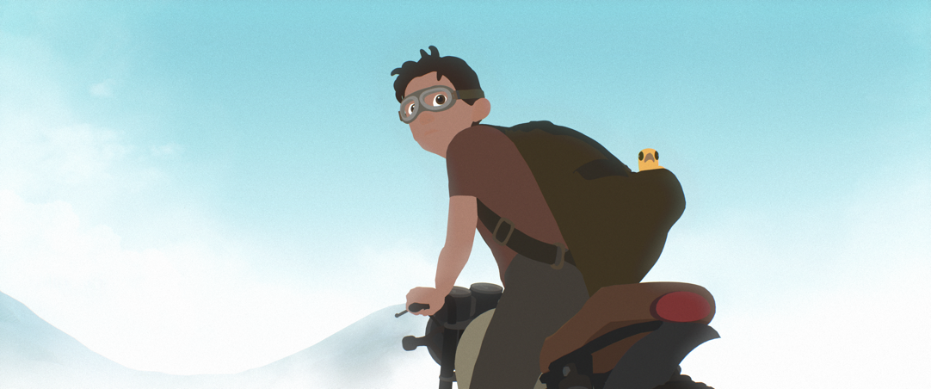
Away is an award-winning debut animation from 26 year old Latvian Gints Zilbalodis, a simple feel good story with a slightly dark undertone that follows the trials of a young boy who finds himself the lone survivor from a plane crash stuck on a strange island.
We follow the boy’s journey across a deserted island inhabited by a just a few animals, of whom he befriends a little yellow bird that becomes his companion. There’s also a giant shadow monster that seems intent on blocking his path; a path marked out with stone arches like a race course that he has to complete.
The animation doesn’t have any dialogue and relies upon visual images to tell the story. Written, animated and scored by Gints, he has single-handedly created this animated world from scratch, a feat not to be too quickly washed over when you consider the long list of credits that usually accompanies an animated feature.

He has managed to create an all-round cohesive world using the animated software to zoom in and out of sweeping landscapes and use close-ups to dramatic effect. Its simplicity is its strength but it is not without a depth of meaning that would appeal to both children and adults. The shadow monster is a little scary, like an island version of the black rabbit in Watership Down, an omnipresent ghoul which is a dark but gentle allegory of life and death.

The film score like the animation itself is simple but effective, complementing the animation perfectly. This is someone learning their craft, showing a real knack for building emotions through simple visuals and sound alone.

Today’s modern animations have never gone down the hyperrealism route with much success, so the basicness of this animation, which switches between rudimentary graphics and impressive dreamscape sketches, doesn’t detract from its overall worthiness.

Gints describes it as being about his own creative journey and what it feels like working on an incredibly challenging project. It certainly makes relaxing viewing, simple but clever and a heart-warming boy’s own story.

Similar films:
- Turbo (2013); Dir: David Soren
- Coraline (2009); Dir: Henry Selick
- Bolt (2008); Dir: Chris Williams, Byron Howard
Exercises:

A. Questions True or False:
1. It’s about a 26 year old plane crash survivor? T/F?
2. On the island there are lots of different animals? T/F?
3. The animator Gints made the animation by himself? T/F?
4. The animation was all hand drawn? T?F?
5. The film’s music and sound complements the animation well? T/F
6. The story is comparable to the animator’s own difficulties completing it? T?F

B. Vocabulary / Phrases Match:
- lone survivor
- single-handedly
- from scratch
- washed over
- close-ups
- omnipresent
- knack
- hyperrealism
- rudimentary
- dreamscape
- zoomed in pictures
- mysterious landscape
- capability
- on your own
- real life looking
- ignore completely
- everywhere
- very basic
- start at the beginning
- only one alive

C. Discussion Questions:
1. Describe what you see in the picture.
2. What would you do if you were stuck on a deserted island?
3. Do you like animation films? Why / why not?
4. Have you ever done a challenging project from scratch?
5. Would you like to go on holiday to a deserted island? Why / why not?

D. Pronunciation & Listening Exercise:
a. Listen to the phrases and practise your pronunciation (double click the icons).
- Away is an award-winning debut animation.
- We follow the boy’s journey across the island.
- Gints describes it as being about his own creative journey.

b. Listen to the text and fill the missing gaps (see text below).
(double click the icon)

E. Writing tasks:
- Write a short story about a desert island (try to use the vocabulary)

Answers:
A. True or False Questions:
- F 2. F 3. T 4. F 5. T 6. T

B. Vocabulary Definitions:
1j, 2d, 3i, 4f, 5a, 6g, 7c, 8e, 9h, 10b

C. Listening Gap Fill
1. plane crash 2. yellow bird 3. dialogue 4. animated software 5. creative journey

Listening Gap Fill
Away
Away is an award-winning debut animation from 26 year old Latvian Gints Zilbalodis, a simple feel good story with a slightly dark undertone that follows the trials of a young boy who finds himself the lone survivor from a 1. _______ _______stuck on a strange island.
We follow the boy’s journey across a deserted island inhabited by a just a few animals, of whom he befriends a little 2. _______ _______ that becomes his companion. There’s also a giant shadow monster that seems intent on blocking his path; a path marked out with stone arches like a race course that he has to complete.
The animation doesn’t have any 3. _______ and relies upon visual images to tell the story. Written, animated and scored by Gints, he has single-handedly created this animated world from scratch, a feat not to be too quickly washed over when you consider the long list of credits that usually accompanies an animated feature.

He has managed to create an all-round cohesive world using the 4. _______ _______ to zoom in and out of sweeping landscapes and use close-ups to dramatic effect. Its simplicity is its strength but it is not without a depth of meaning that would appeal to both children and adults. The shadow monster is a little scary, like an island version of the black rabbit in Watership Down, an omnipresent ghoul which is a dark but gentle allegory of life and death.

The film score like the animation itself is simple but effective, complementing the animation perfectly. This is someone learning their craft, showing a real knack for building emotions through simple visuals and sound alone.

Today’s modern animations have never gone down the hyperrealism route with much success, so the basicness of this animation, which switches between rudimentary graphics and impressive dreamscape sketches, doesn’t detract from its overall worthiness.

Gints describes it as being about his own 5. _______ _______ and what it feels like working on an incredibly challenging project. It certainly makes relaxing viewing, simple but clever and a heart-warming boy’s own story.

