Film: Lost at Christmas
Director: Ryan Hendrick
Stars: Natalie Clark, Kenny Boyle, Sylvester McCoy
Genre: Romance / Comedy

Run time: 1hr 40min
Rated: 12
Rating: 3/5

(Double Click for Audio Listening)
Lost at Christmas

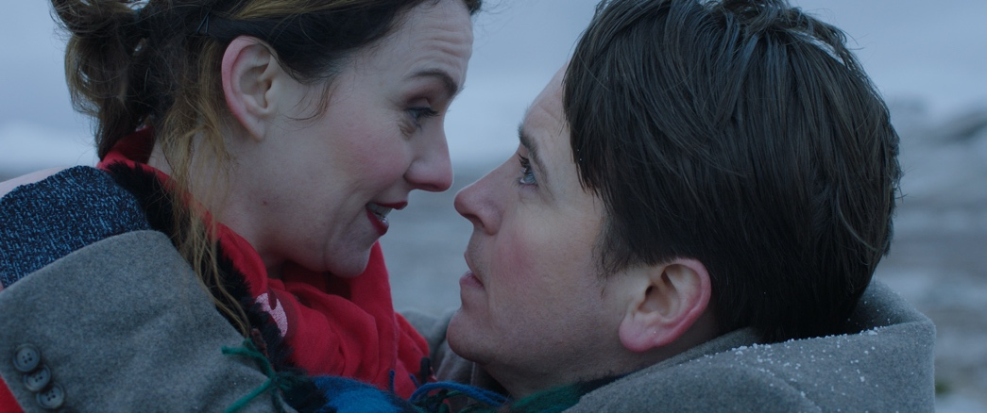

This is Scotland’s first ever Christmas movie coming to UK cinemas from 4th December and is available on digital platforms from 7th December. It’s a quirky romcom that looks to bring a bit of Christmas cheer to our screens whilst taking in some wonderful Scottish Highland scenery.

Director Ryan Hendrick has made a feature length film of his successful short film Perfect Strangers bringing together a collection of Scottish actors in the wonderful surroundings of Fort William and Glencoe. Starring Kenny Boyle as Rob, a foppish Hugh Grant lookalike and Natalie Clark as Jen, the ditsy Christmas romantic dressed as an elf; the two are thrown together as their Christmas Eves end in heartbreak and they decide to team up to help each other get home for Christmas but things don’t go to plan.

Having “borrowed” Jen’s now ex-boyfriend’s car, they get stuck and end up having to cross the moors wearing only an elf’s outfit and lace-up shoes in treacherous snowy conditions, and whilst the scenery looks stunningly beautiful, it’s a relief when they find a guest house before dark, even for hardy Scots. Here they find the other guests getting away for Christmas and there are star turns from Sylvester McCoy (Dr. Who, The Hobbit), Clare Grogan (Gregory’s Girl) and Sanjeev Kohli (Still Game, Stan & Ollie) who plays the welcoming but slightly beleaguered Scottish guest house owner.

The film can’t help looking like a Highlands tourist board commercial with its smattering of product placement in tweed, tartan, whiskey and general Scottish patter. The script also requires an element of acquiescing some of its eccentricities, where the sentiment is missed or the humour remains undelivered but there is plenty of Scottish wit and charm to enjoy.

It’s a delicately twee Christmas romcom and despite all the heartbreak and sorrow of seemingly everyone staying at the guest house, it is still capable of raising the spirits this Christmas time albeit in a slightly low-key manner. It doesn’t chase the happy ever after too much which is refreshing, although perhaps it falls between the two stools.

Similar films:
- Crazy, Stupid, Love (2011); Dir: Glen Ficarrra, John Requa; Stars: Steve Carell, Ryan Gosling
- Love Actually (2003); Dir: Richard Curtis; Stars: Hugh Grant, Martine McCutcheon
- Bridget Jones’s Diary (2001); Dir: Sharon Maguire, Stars: Renee Zellweger, Colin Firth

Exercises
A. Questions True or False:
1. It is a typical romantic comedy? T/F?
2. It’s the full film version of a short film? T/F?
3. The 2 people knew each other before Christmas Eve? T/F?
4. They are well prepared to walk across the moors in the snow? T/F?
5. The film is like an advertisement for Scottish products? T/F?
6. Everybody staying at the guest house is happy it’s Christmas? T/F?

B. Vocabulary / Phrases Match:

1. quirky romcom
2. foppish
3. ditsy
4. hardy
5. star turns
6. beleaguered
7. smattering
8. acquiescing
9. twee
10. falls between the two stools
- good performances
- fails to achieve both aims
- strong endurance
- a small amount of something
- overly interested in fashion
- an unusual romantic comedy
- agree to things reluctantly
- a silly acting female
- having difficulties
- sweet or pretty

C. Discussion Questions:
1. Describe what you see in the picture.
2. What do you know about Scotland?
3. Have you ever been to Scotland? Where did you go / would you like to go?
4. Would you like to go away for Christmas? If so where to?
5. What’s the best / worst Christmas you have ever had?
D. Pronunciation & Listening Exercise:
a. Listen to the phrases and practise your pronunciation (double click the icons).


- This is Scotland’s first ever Christmas movie.
- Director Ryan Hendrick has made a feature length film.

- Having “borrowed” Jen’s now ex-boyfriend’s car.

b. Listen to the text and fill the missing gaps (see Listening Gap Fill page).
(double click the icon)

E. Writing tasks:
- Write a short Christmas romantic / comedy story (try using the vocabulary).

Answers:
A. True or False Questions:
- F 2. T 3. F 4. F 5. T 6. F

B. Vocabulary Definitions:
1f, 2e, 3h, 4c, 5a, 6i, 7d, 8g, 9j, 10b

C. Listening Gap Fill
1. 4th, 2. short film, 3. snowy conditions, 4. product placement, 5. Heartbreak
Listening Gap Fill

Lost at Christmas
This is Scotland’s first ever Christmas movie coming to UK cinemas from 1._____ December and is available on digital platforms from 7th December. It’s a quirky romcom that looks to bring a bit of Christmas cheer to our screens whilst taking in some wonderful Scottish Highland scenery.

Director Ryan Hendrick has made a feature length film of his successful 2. _____ _____Perfect Strangers bringing together a collection of Scottish actors in the wonderful surroundings of Fort William and Glencoe. Starring Kenny Boyle as Rob, a foppish Hugh Grant lookalike and Natalie Clark as Jen, the ditsy Christmas romantic dressed as an elf; the two are thrown together as their Christmas Eves end in heartbreak and they decide to team up to help each other get home for Christmas but things don’t go to plan.

Having “borrowed” Jen’s now ex-boyfriend’s car, they get stuck and end up having to cross the moors wearing only an elf’s outfit and lace-ups in treacherous 3. _____ _____, and whilst the scenery looks stunningly beautiful, it’s a relief when they find a guest house before dark, even for hardy Scots. Here they find the other guests getting away for Christmas and there are star turns from Sylvester McCoy (Dr. Who, The Hobbit), Clare Grogan (Gregory’s Girl) and Sanjeev Kohli (Still Game, Stan & Ollie) who plays the welcoming but slightly beleaguered Scottish guest house owner.

The film can’t help looking like a Highlands tourist board commercial with its smattering of 4. _____ _____ in tweed, tartan, whiskey and general Scottish patter, whilst the script also requires an element of acquiescing some of its eccentricities, where the sentiment is missed or the humour remains undelivered but there is plenty of Scottish wit and charm to enjoy.

It’s a delicately twee Christmas romcom and despite all the 5. _____ and sorrow of seemingly everyone staying at the guest house, it is still capable of raising the spirits this Christmas time albeit in a slightly low-key manner. It doesn’t chase the happy ever after too much which is refreshing, although perhaps it falls between the two stools.

