Film: A Christmas Carol
Director: Jacqui Morris and David Morris
Stars: Simon Russell Beale, Martin Freeman, Carey Mulligan

Genre: Drama / Animation
Run time: 1hr 36min
Rated: PG

Rating: 5/5

(Double Click for Audio Listening)
A Christmas Carol

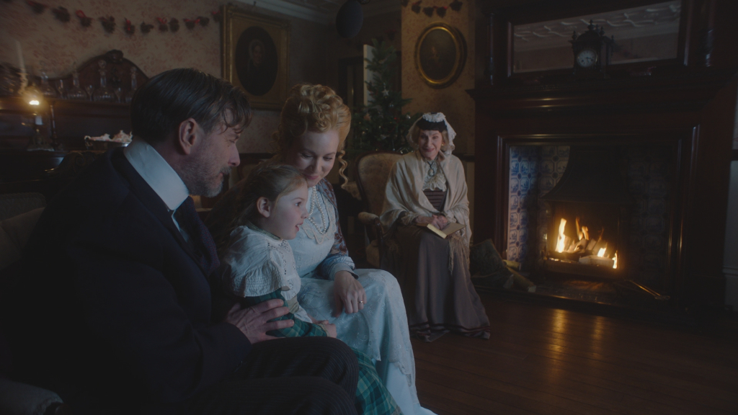

Aiming for a cinema and theatre release from 4th December A Christmas Carol is a masterful remake of the ultimate Christmas ghost story by Charles Dickens, but with a difference. Combining film, theatre and animation it is as ambitious as its planned opening release date at selected cinemas and theatre participants around the country.
The story begins in a Victorian sitting room with grandma and the family assembled by the fireplace readying to be entertained. We magically enter the children’s play house into the Dickensian London setting and the time-honoured story of Ebenezer Scrooge, as the mean business proprietor, who is visited by the ghost of his business partner, Jacob Marley, and the 3 spirits of Christmas: Christmas past, Christmas Present and Christmas Yet to Come.

Behind A Christmas Carol are the exciting creative British film director siblings Jacqui Morris and David Morris (McCullin, Attacking The Devil) who have put together an extraordinary film that brings together the different mediums of film, theatre and animation to effortlessly portray a dream like world, using music and dance, where the cast are played by dancers and are voiced by an array of star-studded actors that includes Martin Freeman and Carey Mulligan. This is all perfectly executed without anyone moving their lips, which somehow works incredibly well adding to the ghostly drama, most notably by thespian Simon Russell Beale as the feared and fearful Scrooge, danced by Michael Nunn (Ballet Boyz).

The script so faithfully resembles the original Dickens novella that this is like your very own celebrity audiobook put to a musical ballet. And what a script, with its contemporary visual updating, that the prose more than equally matches. It is as fresh as the day it was written, so fresh you have to check the book for verification. The musical score takes you back to the past, bringing it to life with a contemporary twist and the choreographed dialogue elevates this with its incredible psychic medium. This is all played out in a theatre set that could be a studio, but all the while sucks you in to a believable ghostly reality, as we follow Scrooge as he is transported away by each of the Christmas spirits.

Similar films:
- The Muppet Christmas Carol (2002); Dir: Brian Henson; Stars: Michael Caine
- Scrooge (1970), Dir: Ronald Neame; Stars: Albert Finney

Exercises:
A. Questions True or False:
- This film version is very similar to previous ones? T/F
- The family are waiting to do something fun? T/F
- Scrooge is visited by 3 ghosts? T/F
- Making the film the directors use only 1 style of filmmaking? T/F
- The actors are played by dancers? T/F
- The film is close to the original book? T/F

B. Vocabulary / Phrases Match:

- masterful remake
- Dickensian London
- time-honoured story
- business proprietor
- siblings
- mediums
- star-studded actors
- without anyone moving their lips
- novella
- psychic
- short story
- well-known story from the past
- brothers and / or sisters
- speaking without opening your mouth
- very good copy
- through the mind
- period of time 19th century England
- company owner
- very famous performers
- communication

C. Discussion Questions:
- Describe what is happening in the picture.
- What do you know about Charles Dickens?
- Have you ever seen a version of A Christmas Carol before?
- Why do people usually say the book is better than the film? Do you agree?
- Which do you prefer film, theatre or animation?

D. Pronunciation & Listening Exercise:
a. Listen to the phrases and practise your pronunciation (double click the icons).
- A Christmas Carol is a masterful remake.
- The story begins in a Victorian sitting room.
- The script so faithfully resembles the original Dickens novella.

b. Listen to the text and fill the missing gaps (see Listening Gap Fill page).
(double click the icon)

E. Writing tasks:
- Write a short Christmas / ghost story (try using the vocabulary).

Answers:
A. True or False Questions:
- F 2. T 3. F 4. F 5. T 6. T

B. Vocabulary Definitions:
1e, 2g, 3b, 4h, 5c, 6j, 7i, 8d, 9a, 10f

C. Listening Gap Fill
- 4th December, 2. the fireplace, 3. animation 4. audiobook, 5. musical score
Listening Gap Fill

A Christmas Carol

Aiming for a cinema and theatre release from 1. _____ _____ A Christmas Carol is a masterful remake of the ultimate Christmas ghost story by Charles Dickens, but with a difference. Combining film, theatre and animation it is as ambitious as its planned opening release date at selected cinemas and theatre participants around the country.
The story begins in a Victorian sitting room with grandma and the family assembled by 2. _____ _____ readying to be entertained. We magically enter the children’s play house into the Dickensian London setting and the time-honoured story of Ebenezer Scrooge, as the mean business proprietor, who is visited by the ghost of his business partner, Jacob Marley, and the 3 spirits of Christmas: Christmas past, Christmas Present and Christmas Yet to Come.

Behind A Christmas Carol are the exciting creative British film director siblings Jacqui Morris and David Morris who have put together an extraordinary film that brings together the different mediums of film, theatre and 3. _____ to effortlessly portray a dream like world, using music and dance, where the cast are played by dancers and are voiced by an array of star-studded actors that includes Martin Freeman and Carey Mulligan. This is all perfectly executed without anyone moving their lips, which somehow works incredibly well adding to the ghostly drama, most notably by thespian Simon Russell Beale as the feared and fearful Scrooge, danced by Michael Nunn.

The script so faithfully resembles the original Dickens novella that this is like your very own celebrity 4. _____ put to a musical ballet. And what a script, with its contemporary visual updating, that the prose more than equally matches. It is as fresh as the day it was written, so fresh you have to check the book for verification. The 5. _____ _____ takes you back to the past, bringing it to life with a contemporary twist and the choreographed dialogue elevates this with its incredible psychic medium. This is all played out in a theatre set that could be a studio, but all the while sucks you in to a believable ghostly reality, as we follow Scrooge as he is transported away by each of the Christmas spirits.

